A

Practical File

On

Data ware house and data mining

Paper Code: ITD08



Bachelor of Engineering

(2016-2020)

Computer Science Engineering

**Submitted By:**

Kavita Maurya

Batch-3

Group-1

2016UCO1579

**DIVISION OF COMPUTER SCIENCE ENGINEERING**

**NETAJI SUBHAS UNIVERSITY OF TECHNOLOGY, DWARKA**

**1.**

**AIM:**

Write a procedure for Visualization for Weather Table.

**DESCRIPTION:**

This program calculates and has comparisons on the data set selection of attributes and methods of manipulations have been chosen. The Visualization can be shown in a 2-D representation of the information.

**PROCEDURE:**

1. Create or download **Weather.arff** file having weather data.
2. Click on weka and then click on explorer.



1. Explorer shows many options. In that click on ‘open file’ and select the arff file.

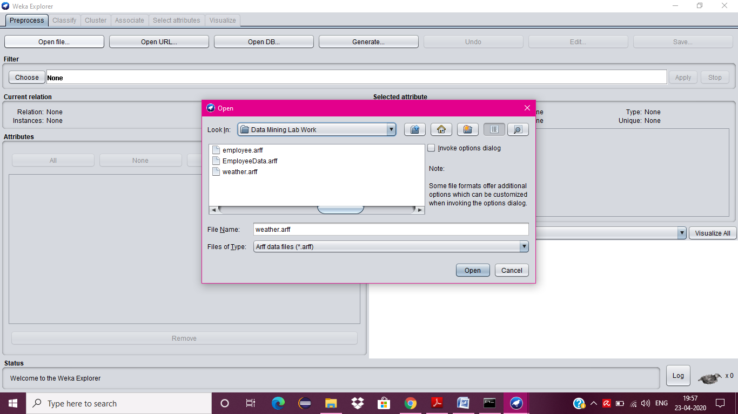

1. Click on edit button which shows weather table on weka.

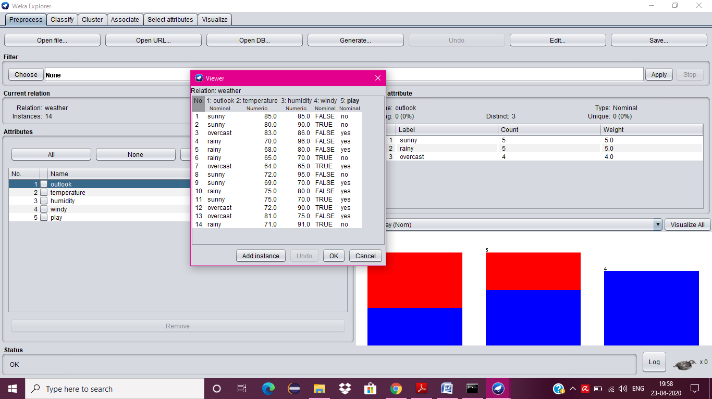

1. Close the file.
2. Now click on Visualize tab.

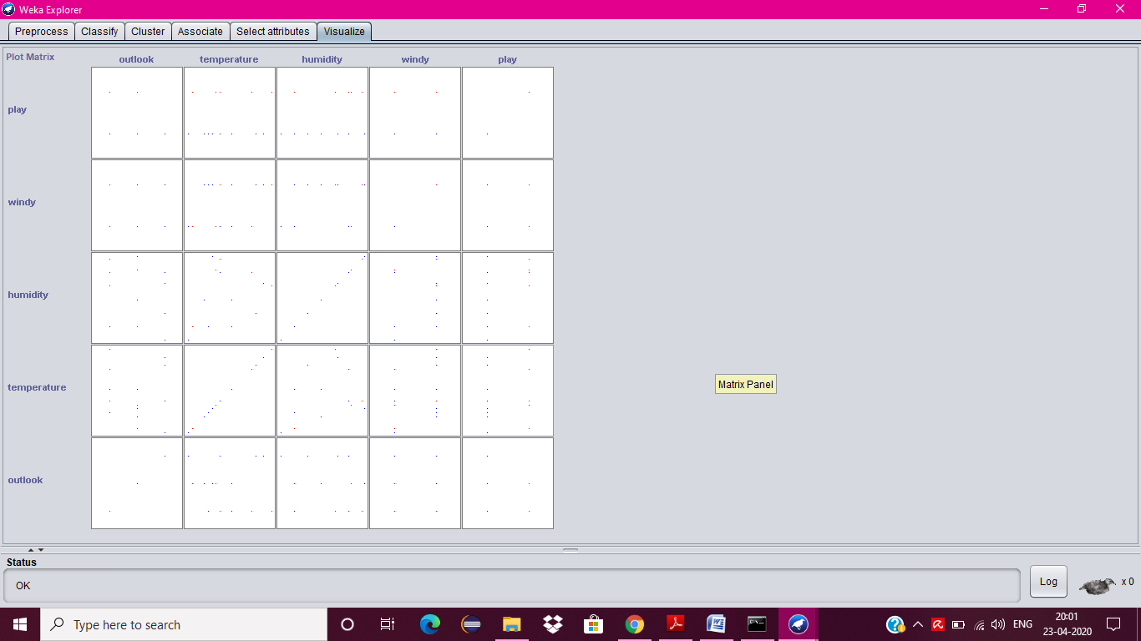

1. Now visualize each attribute one by one.
2. Select the **Select Attribute button**, then select **Outlook attribute** and clock OK.
3. Click on the update button to display the output.
4. Increase the point size and plot size.

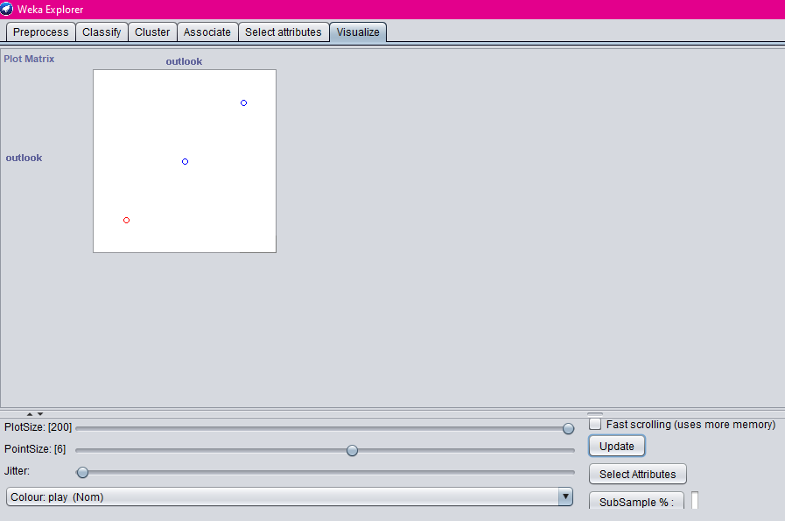

1. Repeat step 8 and 9 for other attributes also.
2. Temperature

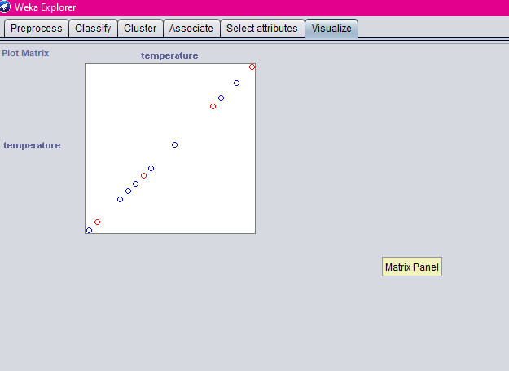

1. Humidity

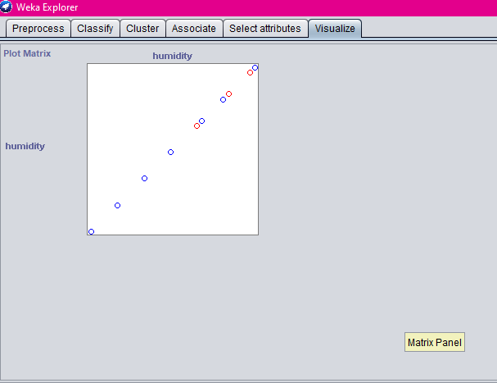

1. Windy

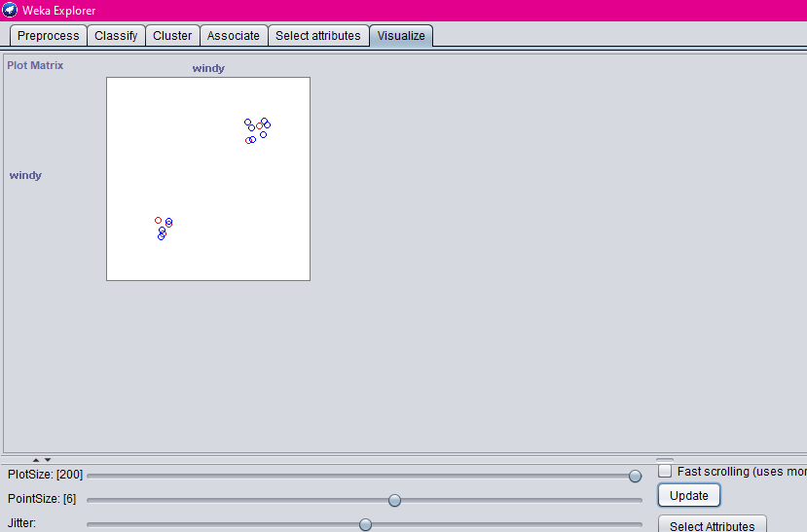

1. Play

